**Boolean algebra**

**Multiplication**

**Addition**

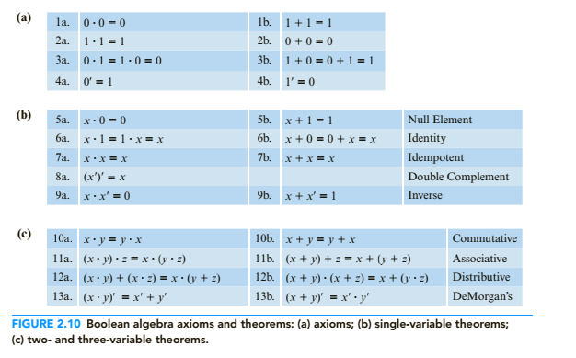

**Double complement identity**

$${\left(A^{'}\right)}^{'}=A$$

**Boolean rules for simplification**

1)

2) (Substitute (A + AB) for A rule 1, Factor B, 9b, 6a)

3) (Prove Distributive) Distribute, 7a, rule 1 A+AC=A, rule 1 A+AB=A